Q1) FORM CREATION AND REGISTRATION

**Step 1:** Copy all the pll’s and template and appstand

Now, Navigate to the Resource path and Find Appstand and Template

The Path is : D:\rajasekhar\forms assignments

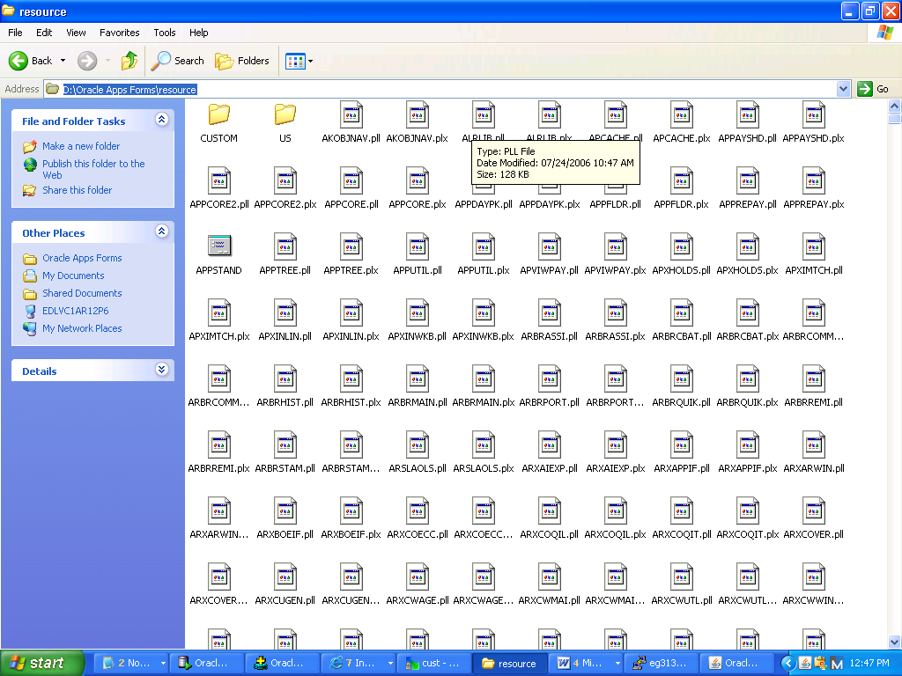

**Step 2 :** Open AppStand and Template, save the template as TEMPLATE

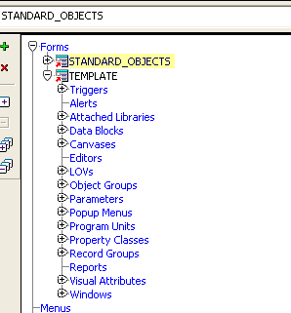

**Step 3:** Navigate to property palette Of TEMPLATE and Change the name to TEMPLATE

**Step 4 :** Delete the Blockname in DataBlock, Canvas and Window

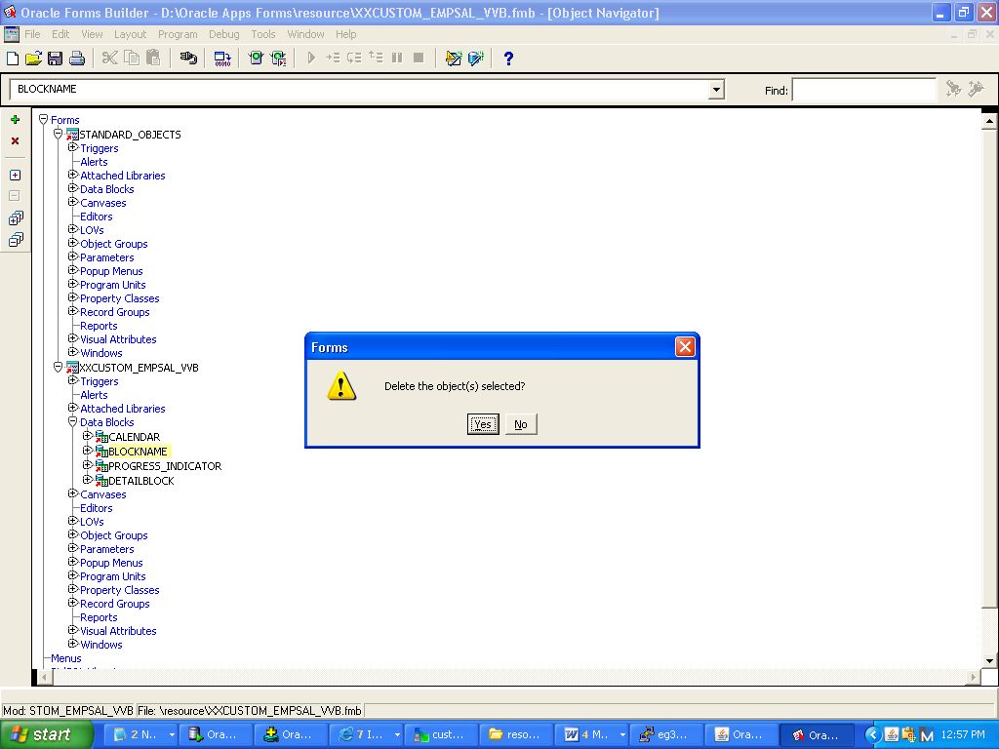

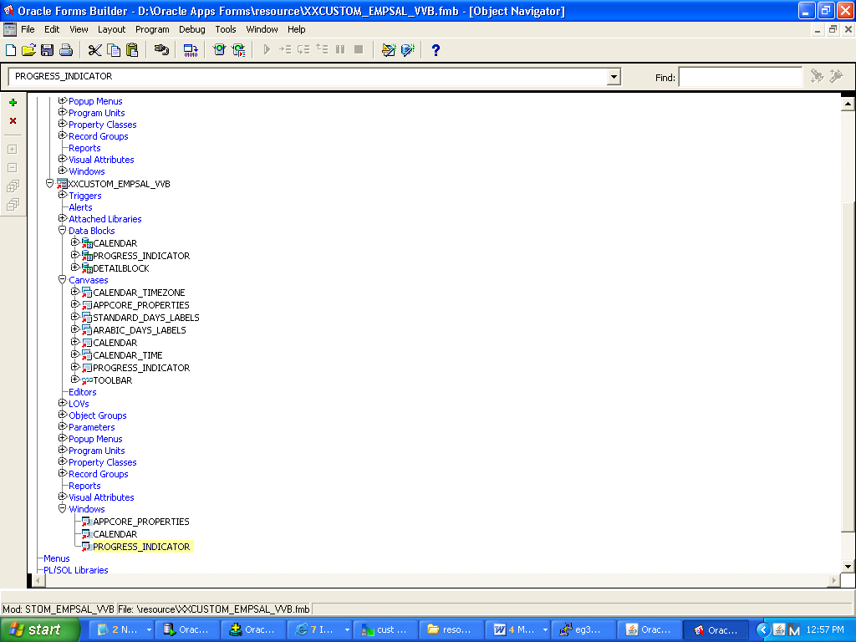

**Step 5:** Create a New Block in datablock by selecting Create

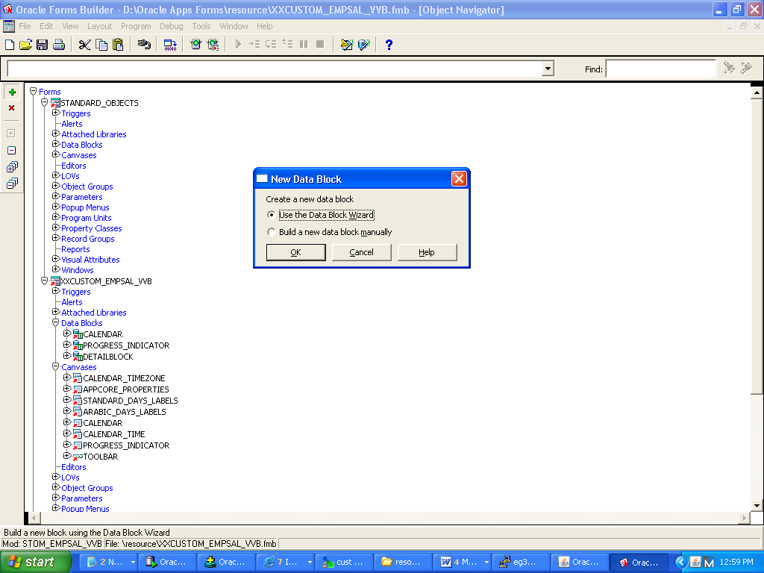

**Step 6:** The below are the following steps that get for the creation of a new data block

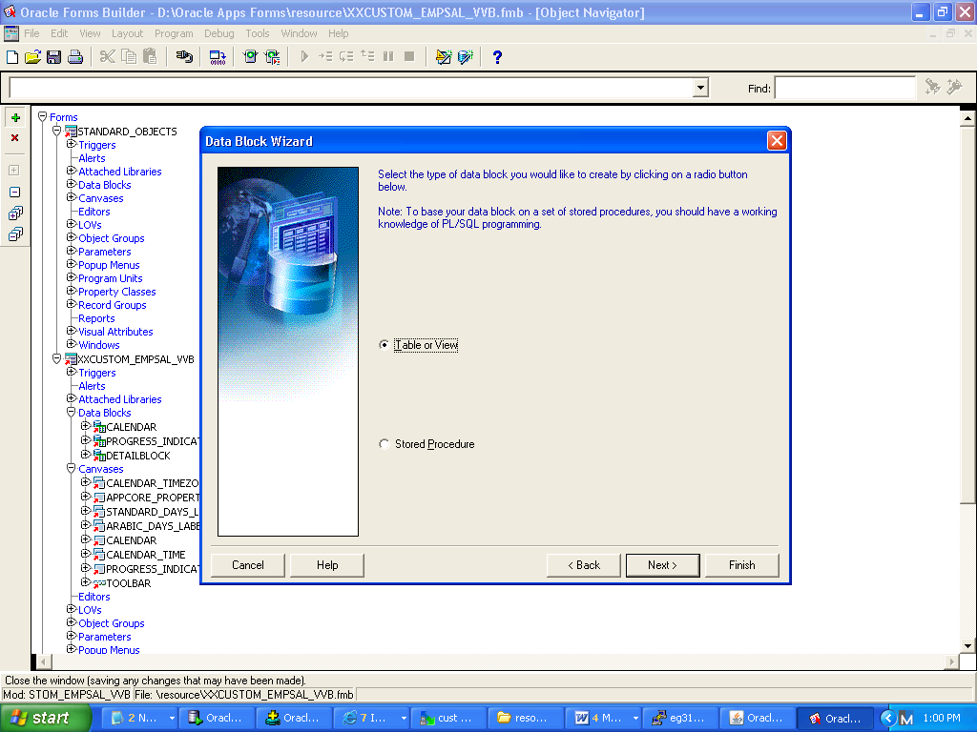

**Step 7:** Provide the table name as EMP which is same as the view name

**Step 8 :** Connect to the server providing the currently used database credentials

USERNAME: apps

Password: apps

Database Used here is “EG30790”

**Step 9:** The required table gets fetched with the following column names

**Step 10:** Select all the column names

**Step 11:** Since any kind of relationship creation is not needed, the following step is ignored

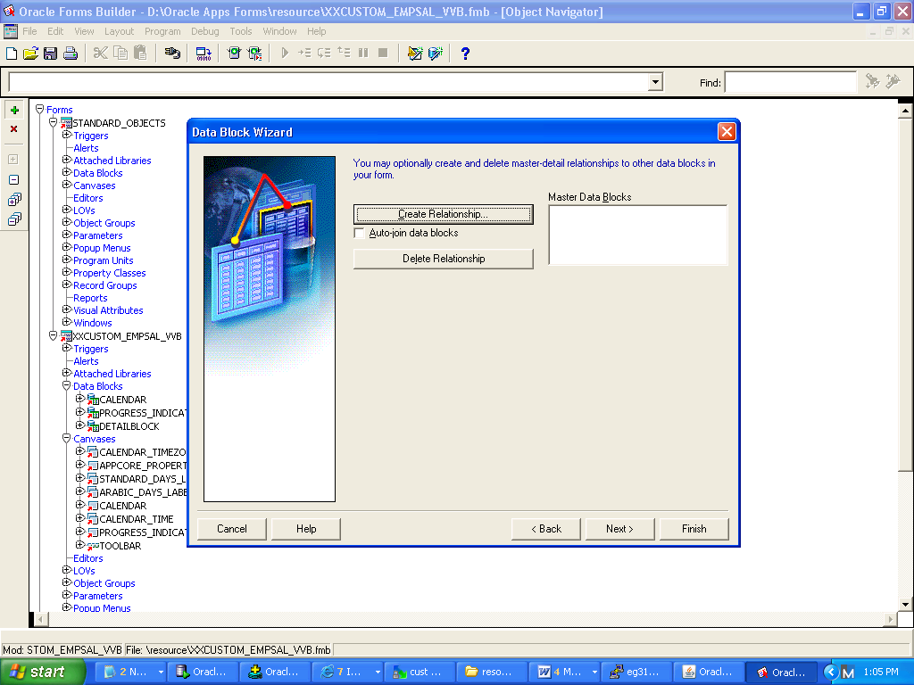

**Step 12:** The block name is given same as the table name

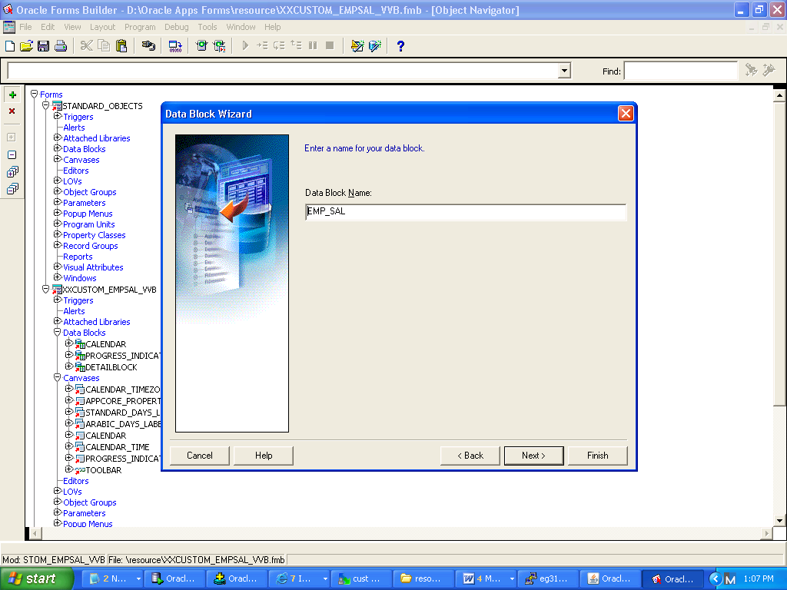

**Step 13:** Now the data block is successfully described

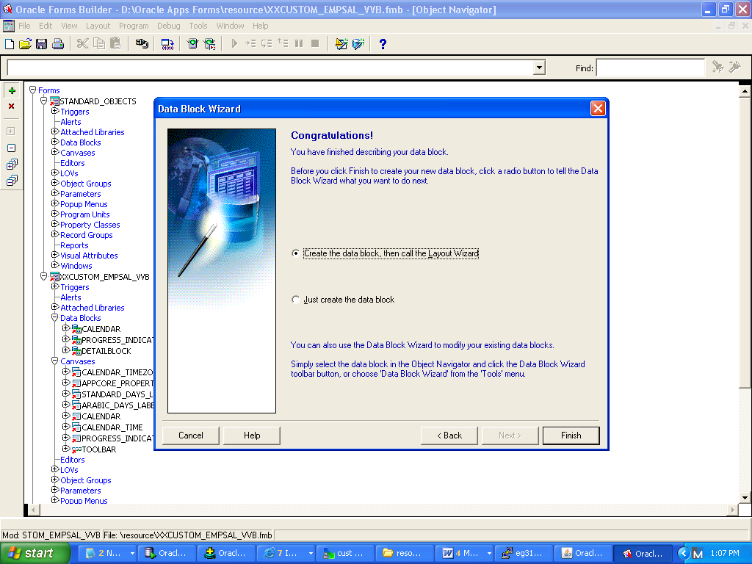

**Step 14:** Now the layout wizard automatically gets invoked

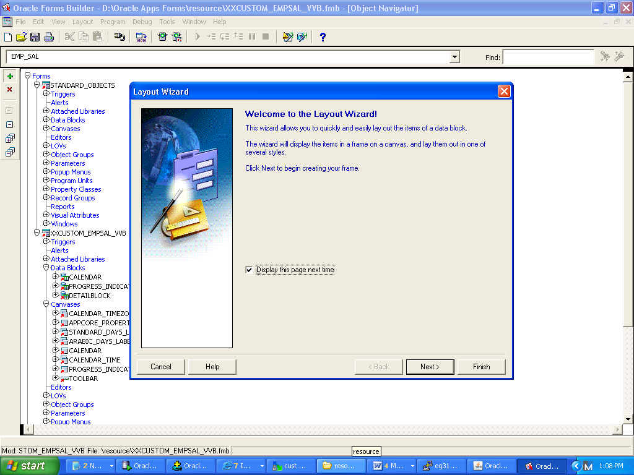

**Step 15:** Select a new canvas here

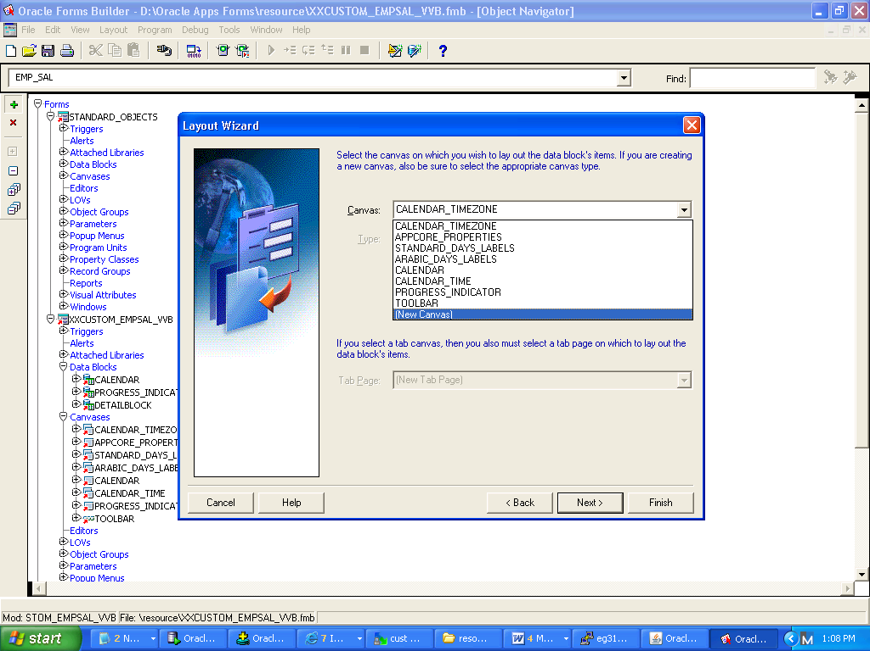

**Step 16 :** Select all the columns to the display Items from the available items

**Step 17:** Change the prompt names

**Step 18:** Select Form

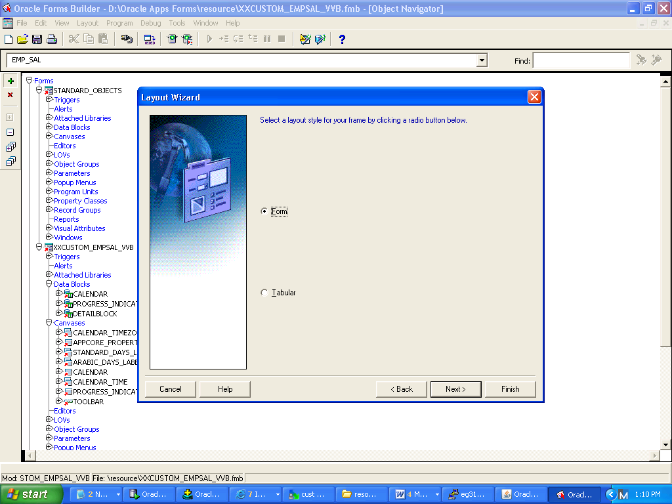

**Step 19:** The Frame title is given as “EMP_FRAMES”, the number of records to be displayed are 5 at a time and the scroll bar is activated

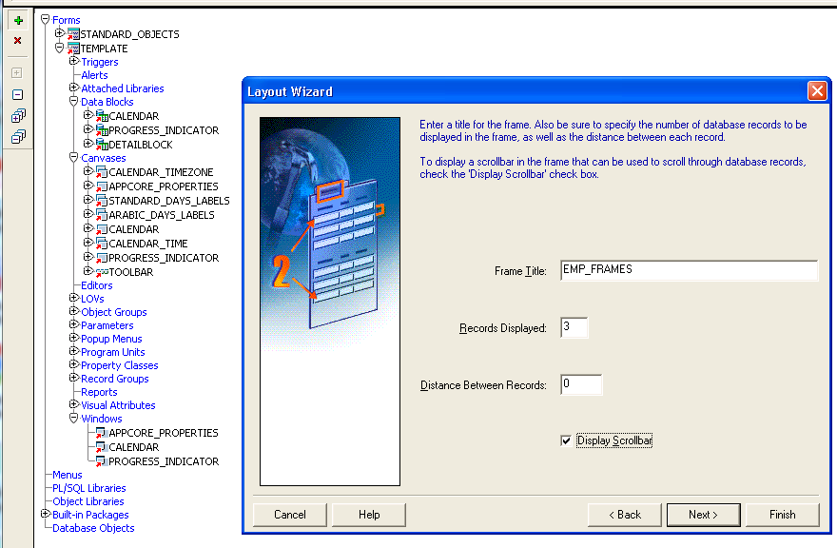

**Step 20 :** The layout is created

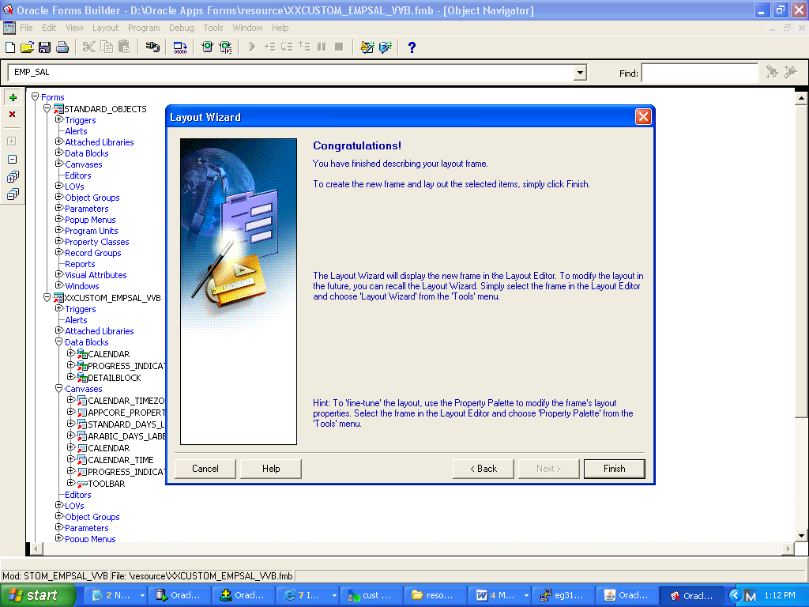

**Step 21:** The Created Form is as shown below

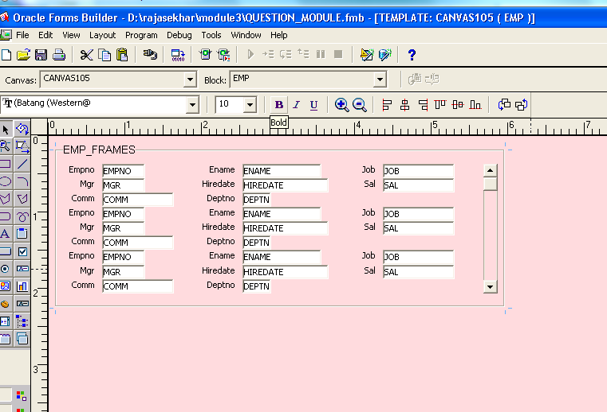

**Step 22:** Select the frame and navigate to frame properties. There change the frame name to “EMPLOYEE_FRM”

Subclass : Property class to FRAME_RECT

Update Layout – manually

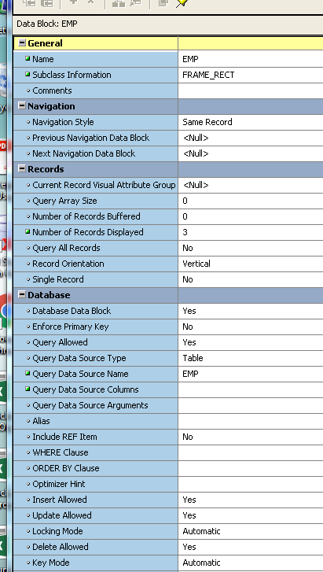

**Step 23:** re-arranging the tabs if REQUIRED

**Step 24:** Now save and exit the form

Create a new window

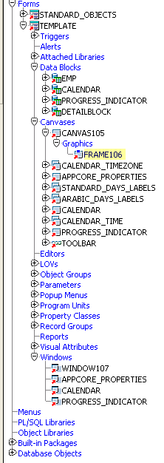

**Step 25:** Navigate to Property class of the window and change the name to WINDOW107

And subclass to window

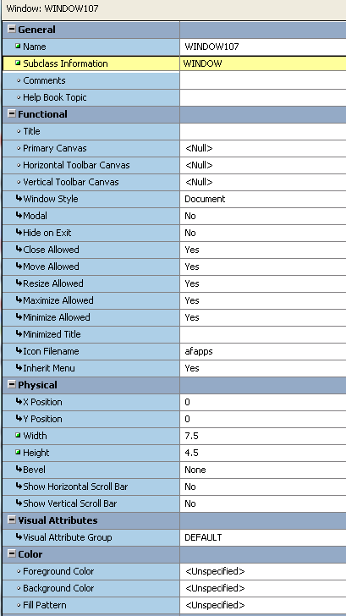

**Step 26:** Now switch to canvas

Change the canvas name to EMPSAL

Subclass to Canvas

And Window to CANVAS105

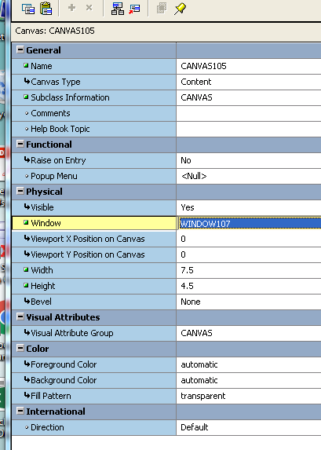

**Step 27:** Now CANVAS105 in the canvas is dragged on to the top of the window



**Step 28:** Navigate to Block and change the block name to EMP and the Subclass name to Block



**Step 29 :** Now Pre-form Triggers are to be Set and the changes are to be made as shown

Template Form to CUSTOM EMPSAL FORM

FND to CUSTOM

Author to : appldev

BLOCKNAME to WINDOW107

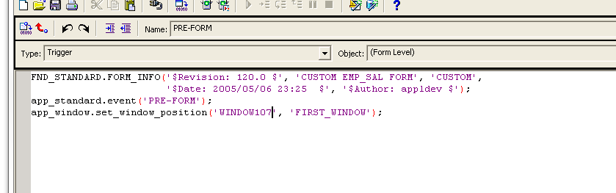

FND_STANDARD.FORM_INFO('$Revision: 120.0$', 'CUSTOM EMPSAL FORM', 'CUSTOM',

'$Date: 2005/05/06 23:25 $', '$Author: TEST_USER_VVB $');

app_standard.event('PRE-FORM');

app_window.set_window_position('EMPSAL', 'FIRST_WINDOW');

**Step 30:** Now it is saved and compiled

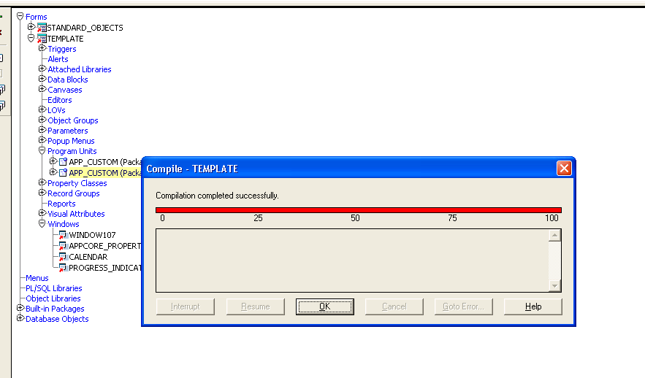

**Step 31:** Switch to program unit and navigate to BODY and change the assigned window name and save it

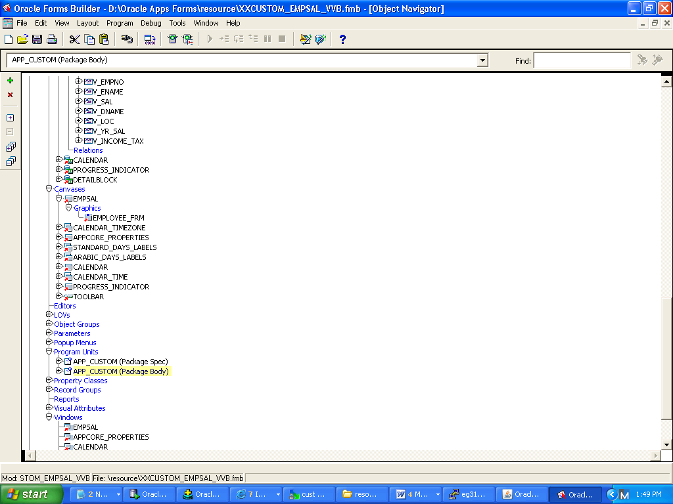

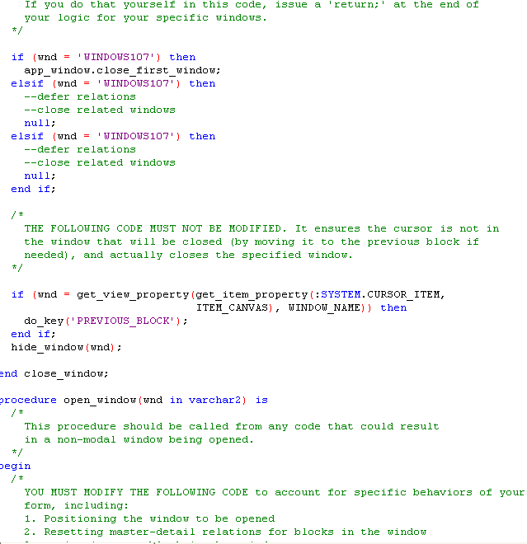

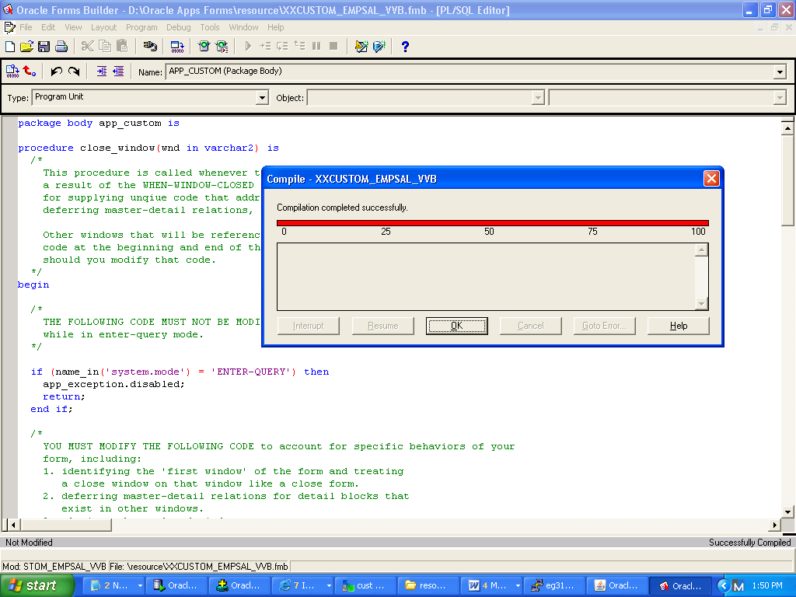

**Step 32:** Now the entire form is compiled successfully

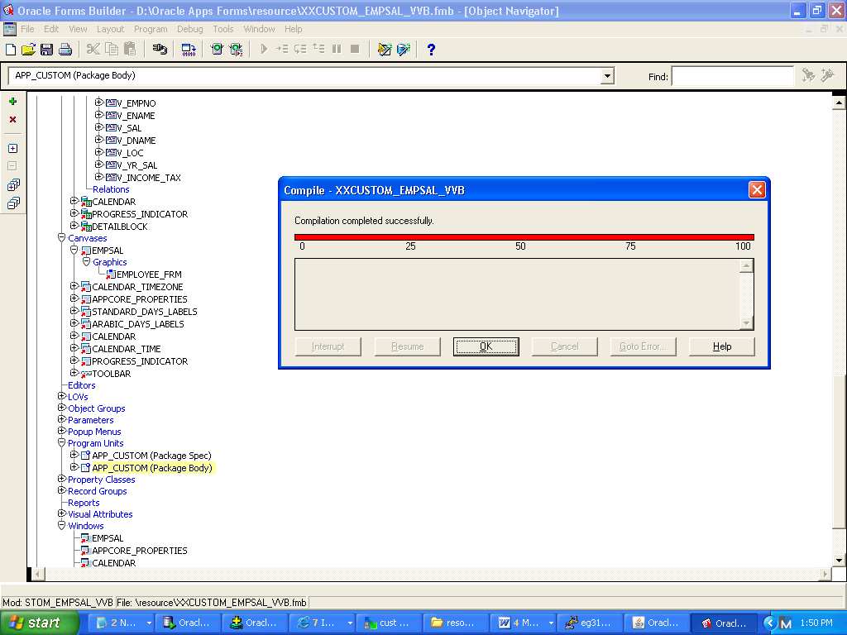

The form is created

* 1. To Create the custom responsibility the following steps are to be followed

**Step 1:** copy the question_module.fmb to the cust top directory path

From resource file path : D:\rajasekhar\forms assignments

To Cust forms path: /dbfiles/applcsf/cust/forms/US

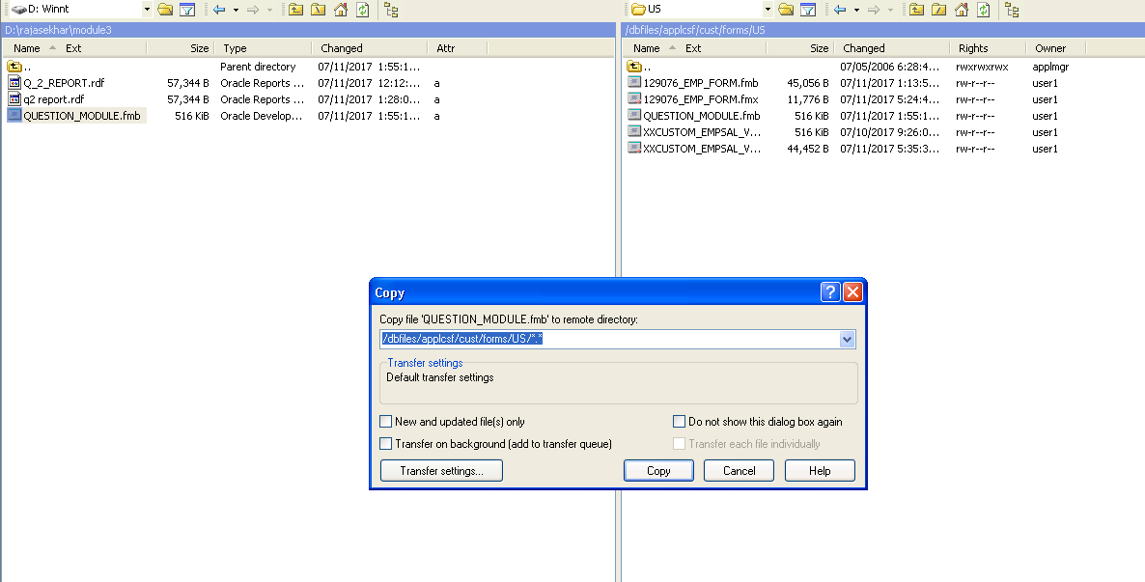

**Step 2:** So as to create an fmx file go to putty and type the following commands

$ cd $CUST_TOP/Forms/US

$ frmcmp_batch userid=apps/apps Module=QUESTION_MODULE.fmb

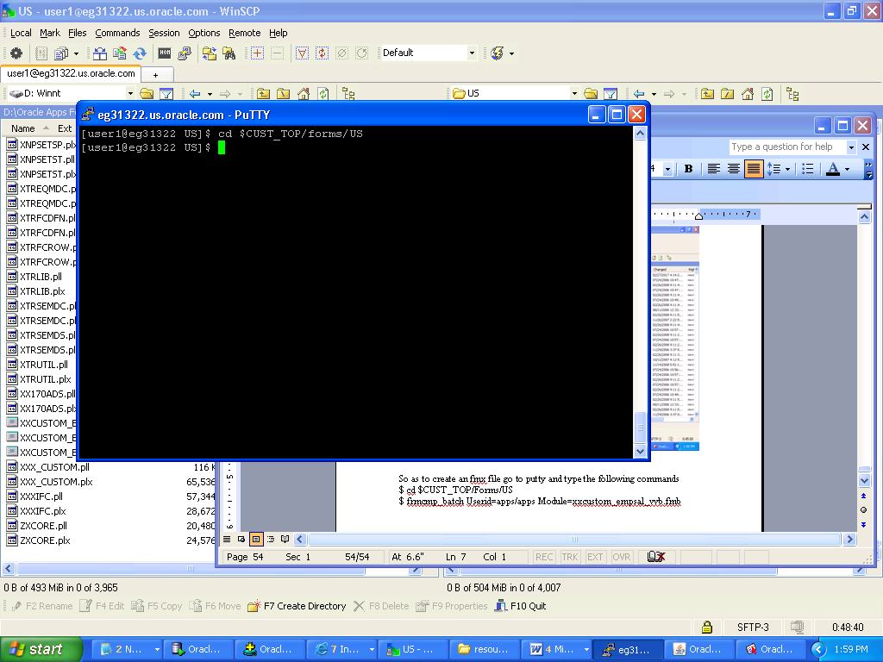

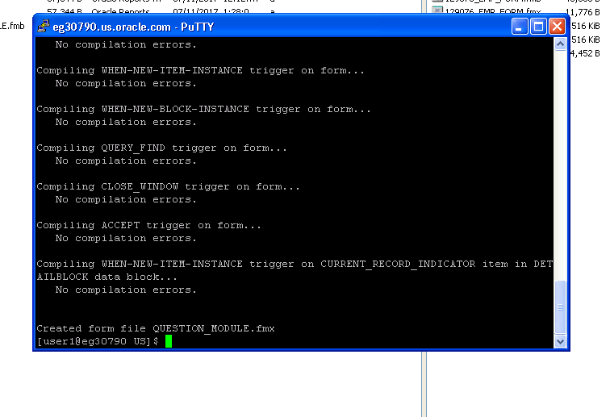

**Step 3:** Now the fmx file is created.

The file is ready to be assigned to custom responsibility

Switch to Oracle application Forms:

Switch responsibility to Application Developer

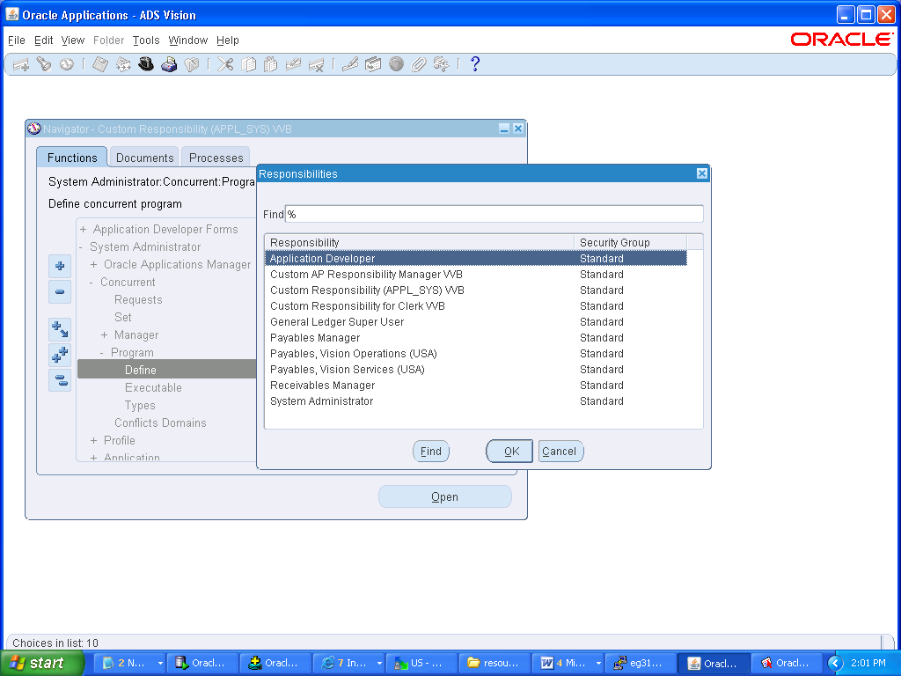

**Step 4:** Navigate to Application and Form, Here create a new form with the following inputs:

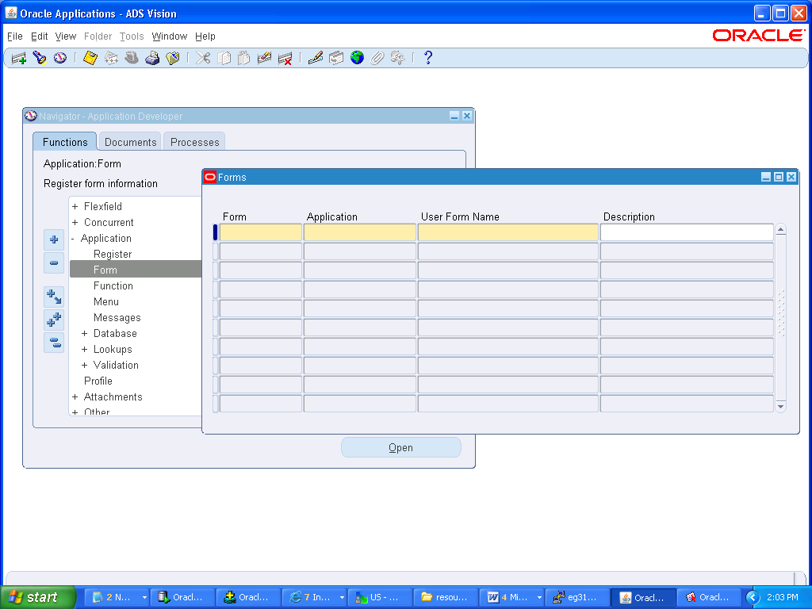

FORM- QUESTION_MODULE

Application- Custom Development

User Form name – Custom QUSTION_MODULE Form

Description- Custom QUESTION_MODULE Form

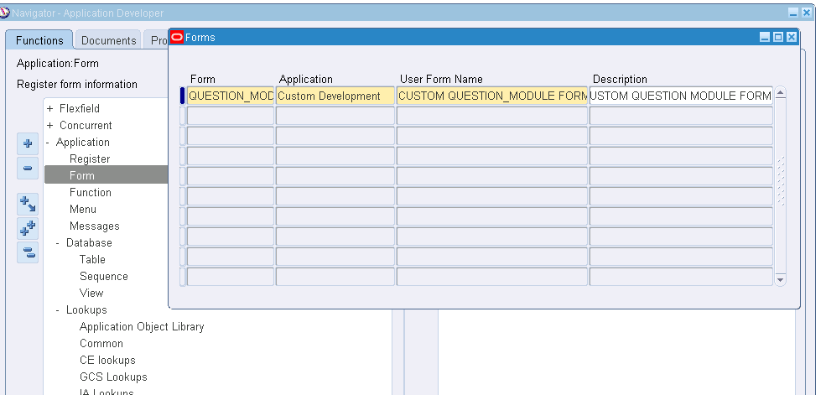

**Step 5:** Now create a function

In description tab –

Function name – QUESTION_MODULE_FUNCTION

User Function Name – Custom QUESTION_MODULE FUNCTION

Description – Custom QUESTION MODULE FUNCTION

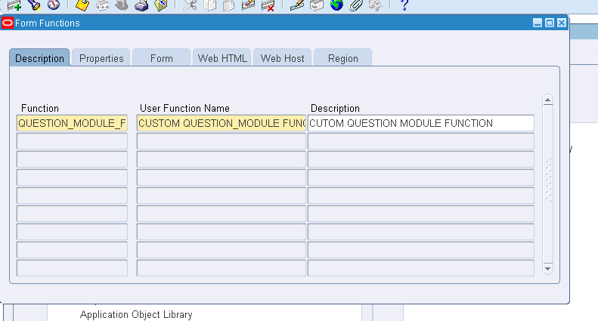

**Step 6:** In Properties tab –

FORM – Form

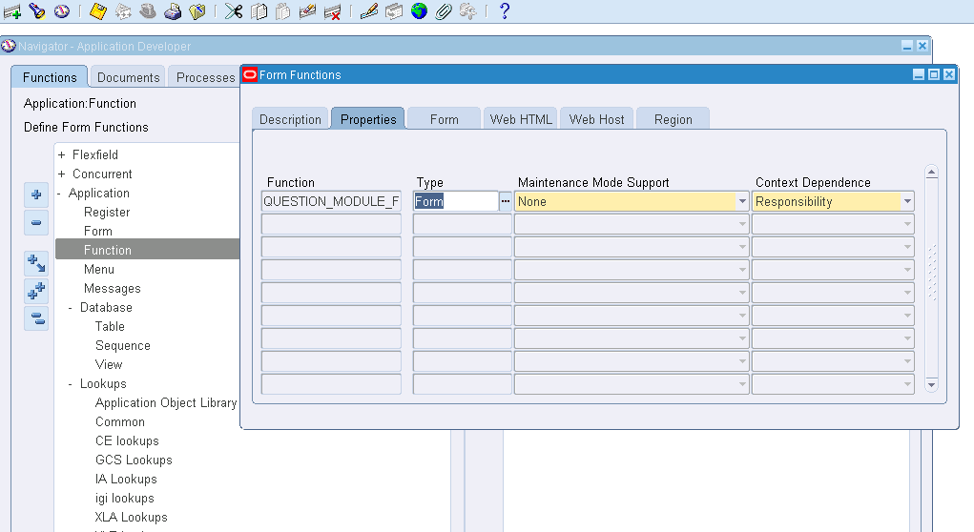

**Step 7:** In FORM Tab-

Form- query the record and enter CUSTOM QUESTION_MODULE FORM

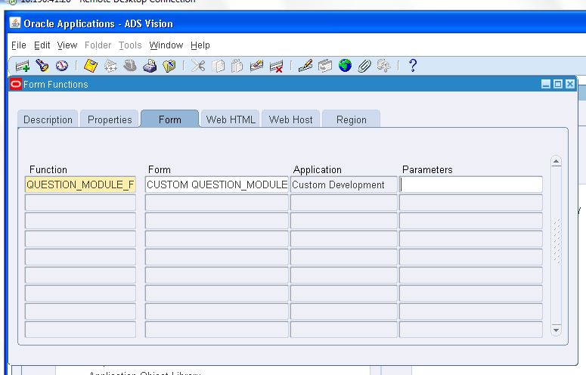

**Step 8:** Now the form is to be attached to the custom menu

Navigate to menu

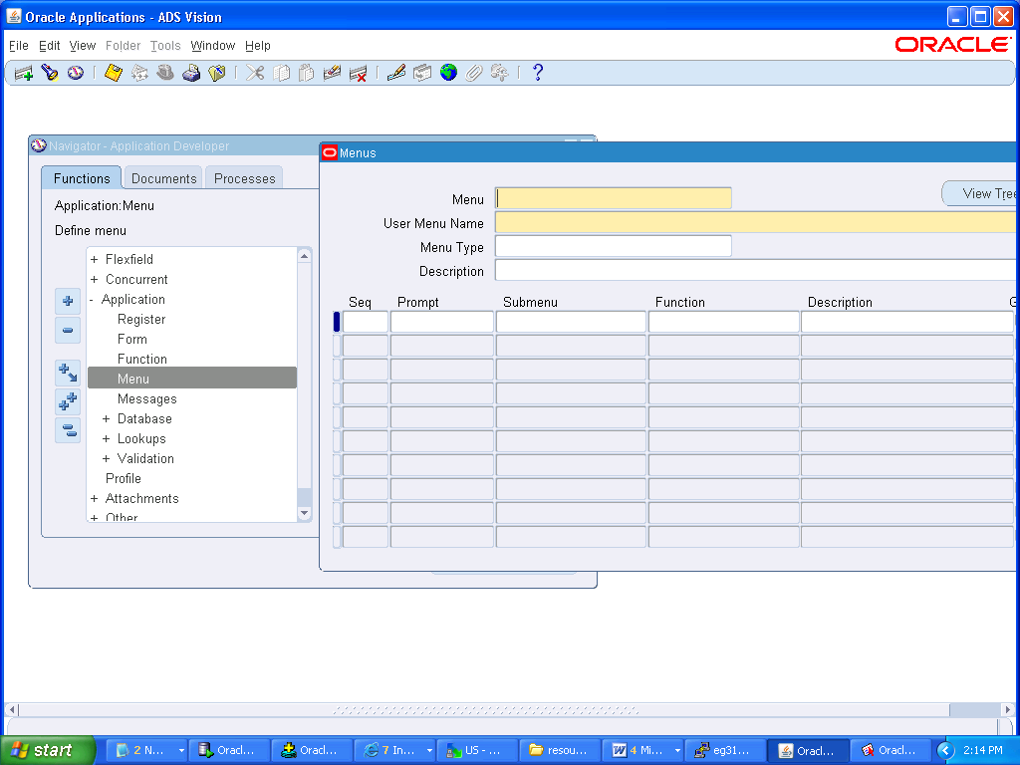

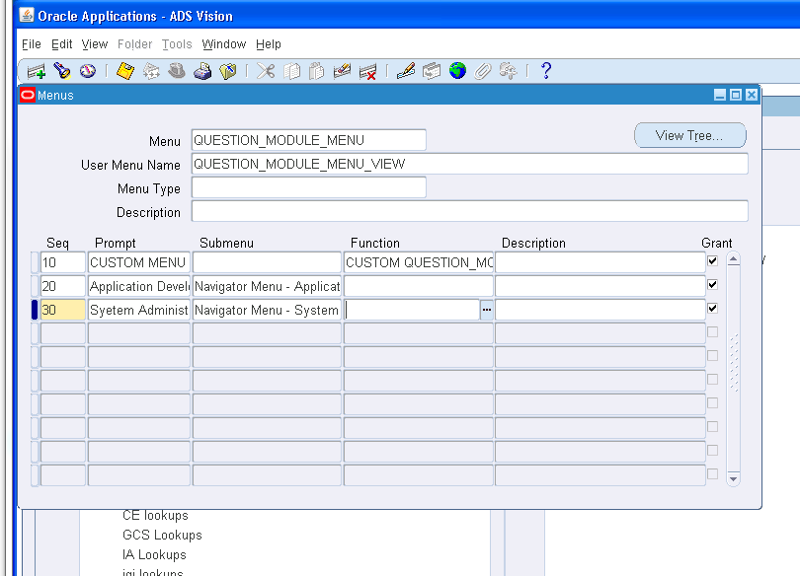

**Step 9:** Query the menu with name and add the created function



**Step 10:** Now save and exit the Form

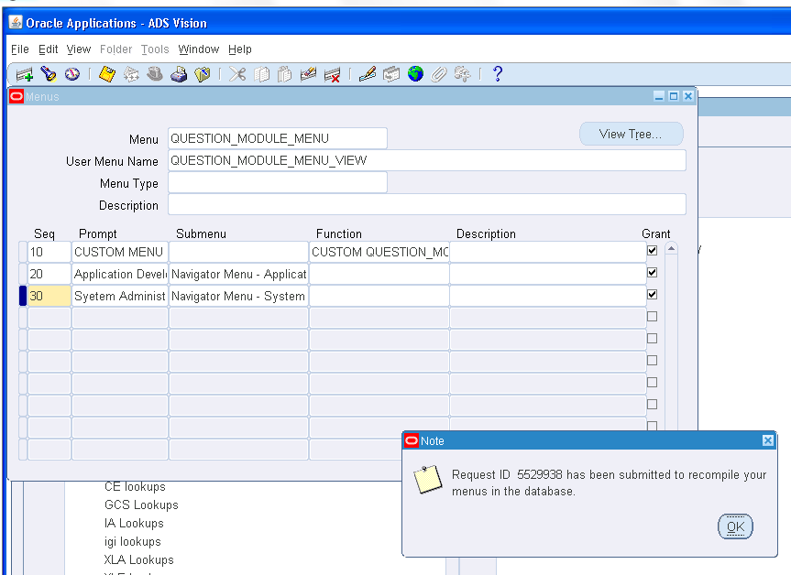

**Step 11:**Now Switch to custom responsibility

**Step 12:**Double click on Custom EMPSAL Function created

**Step 13:**Enter into query mode by F11

**Step 14:**Then run the form by selecting view -> query by Example -> Run

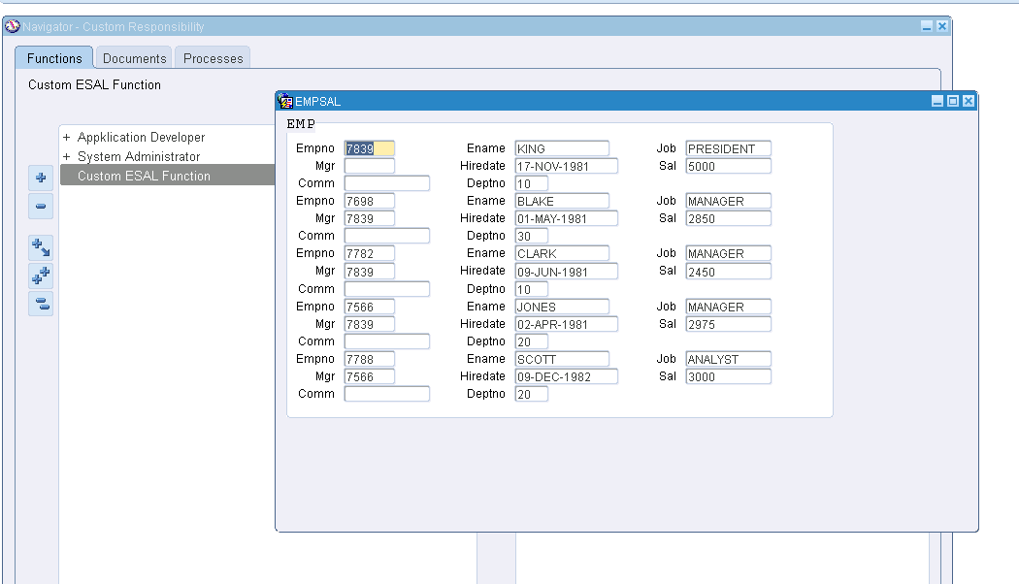

The above is the output once it is assigned to custom responsibility